Install the Stackstorm Application
bash <(curl -sSL https://stackstorm.com/packages/install.sh) --user=st2admin --password=Ch@ngeMe
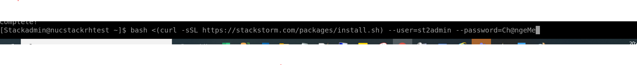
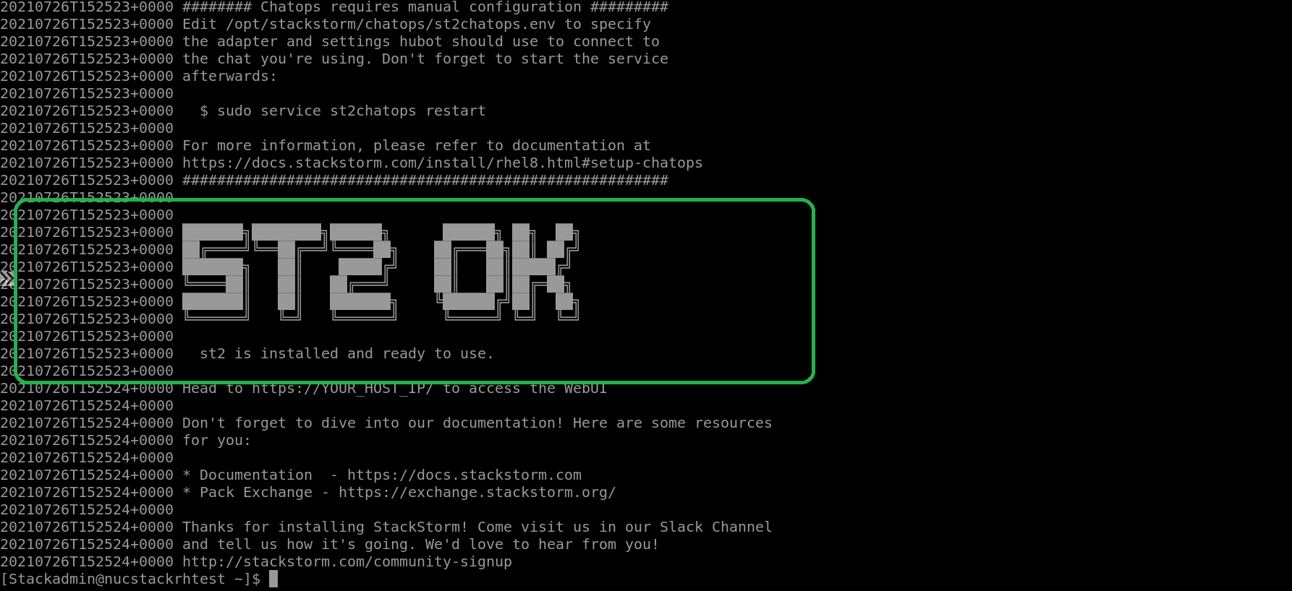
Successfully installed Stackstorm.

Validate :

[Stackadmin@nucstackrhtest ~]$ st2 execution list
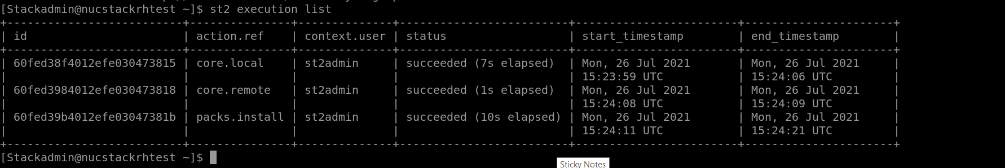

[Stackadmin@nucstackrhtest ~]$ st2ctl reload
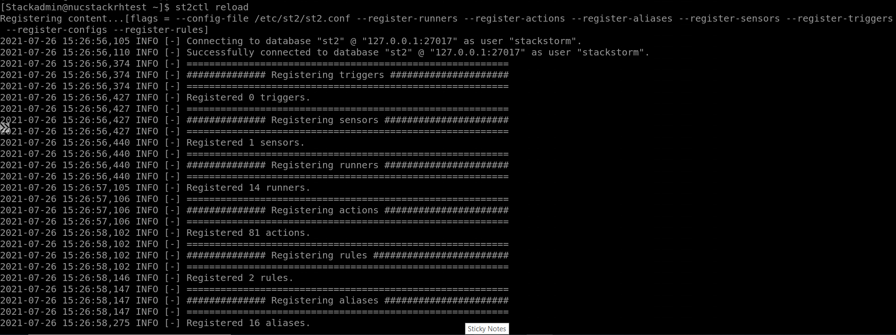
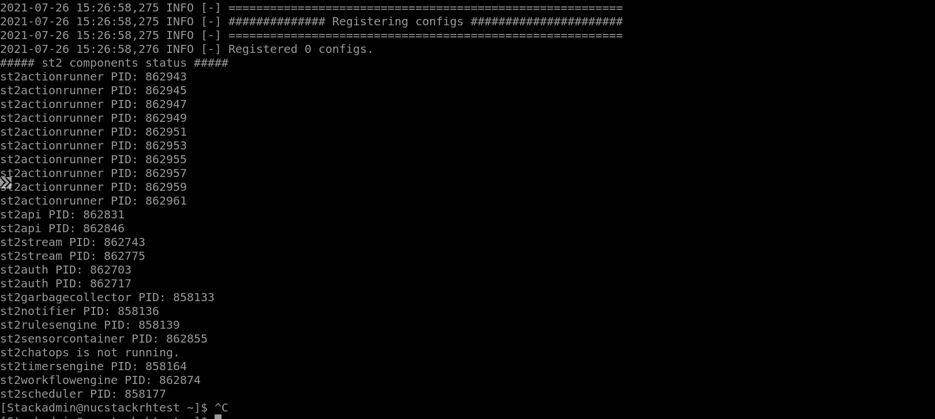

Validate the application path:
Change the application directory
cd /opt/stackstorm

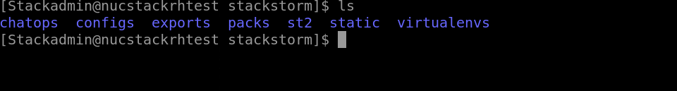
Check the above folders should be there in the application folder path.

Install the puppet-bolt

Command: sudo yum install puppet-bolt

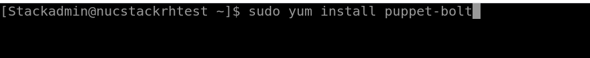

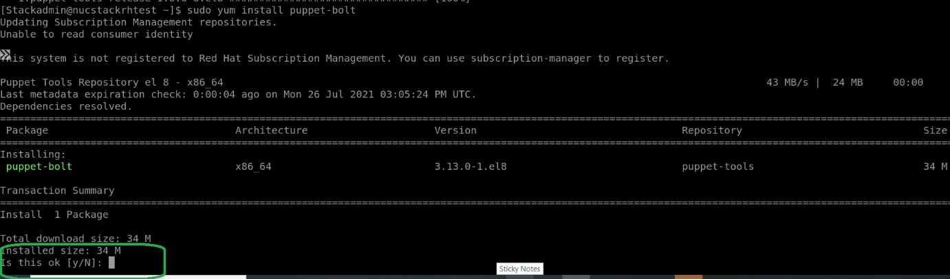

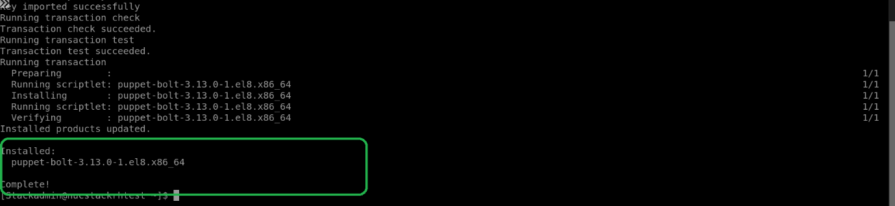

Now the puppet- bolt installed.

Install the expect module
sudo yum install expect

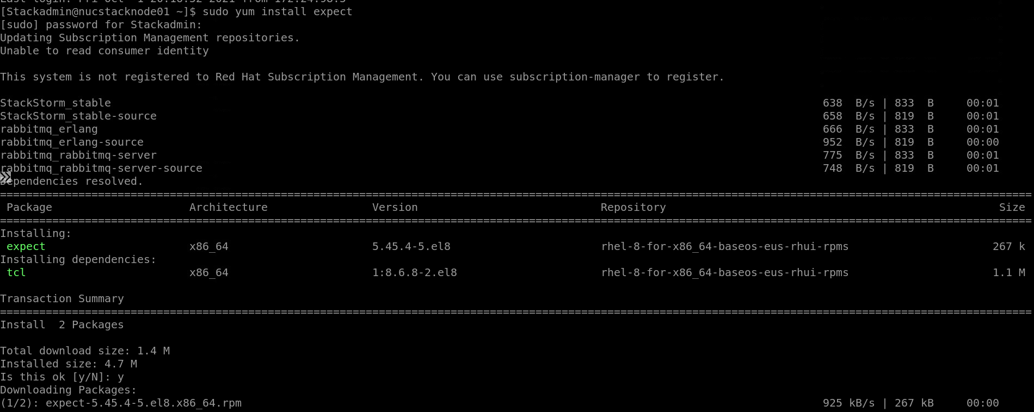

Install SNMP Utility
sudo yum install net-snmp-utils net-snmp
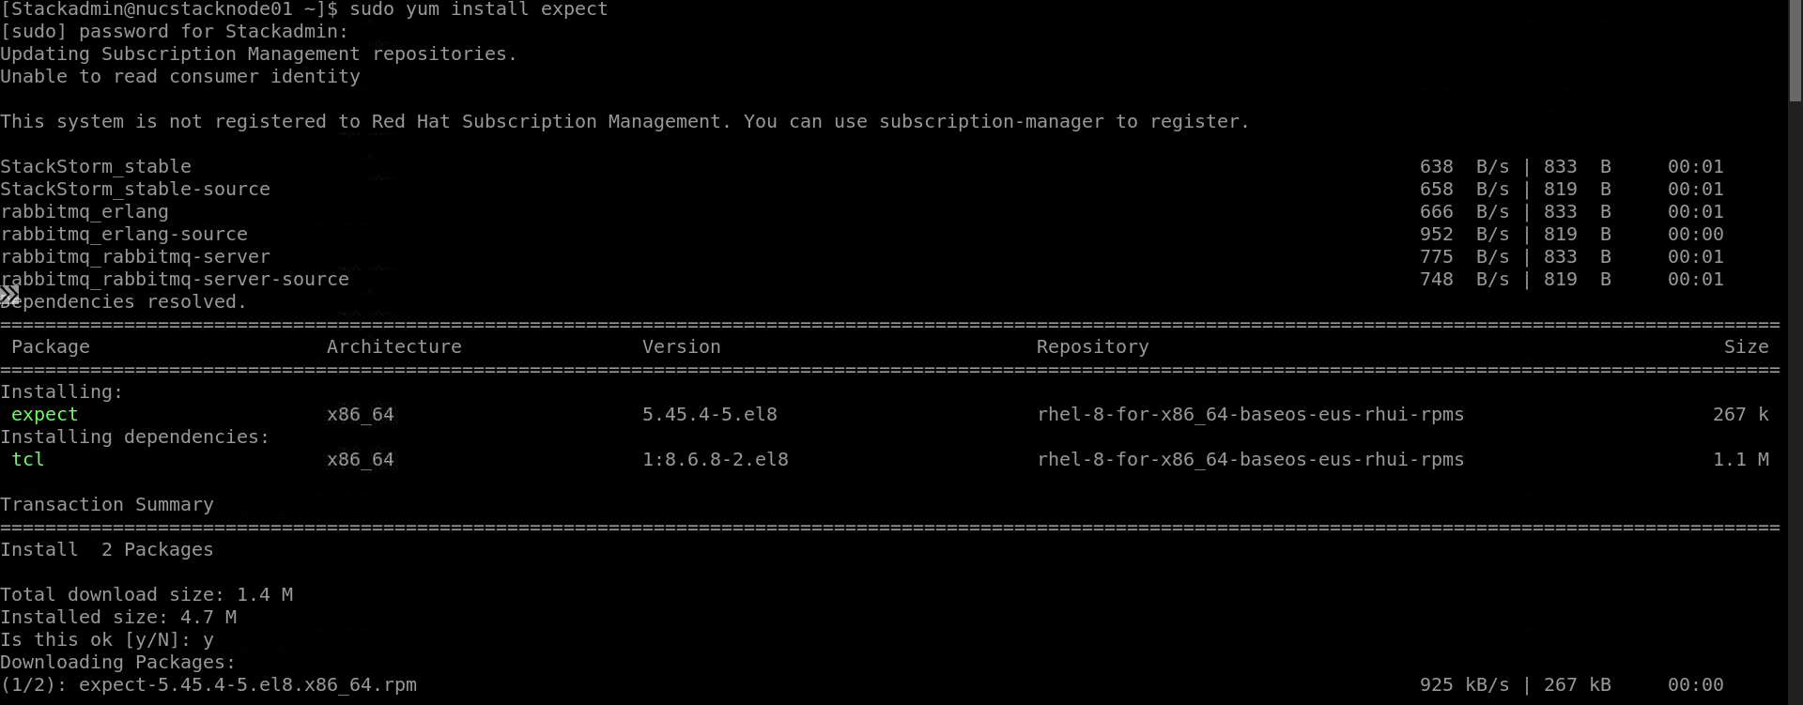
Start SNMP Service
$ sudo systemctl start snmpd
Check SNMP Service
$ sudo systemctl status snmpd
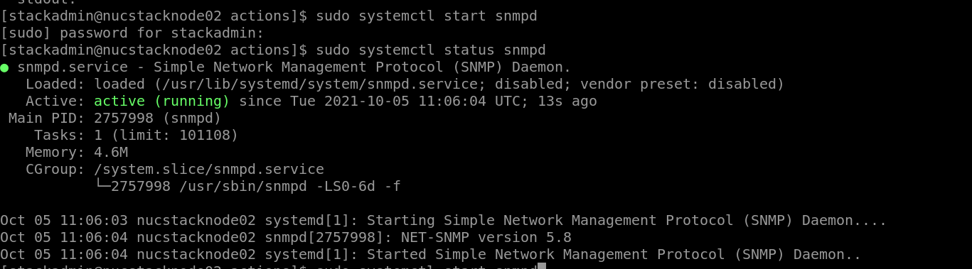

Clone the Ntt_itsm pack from Github Repo
sudo git clone https://github.com/NTT-DATAStackStormRepo/stackstorm-ntt_itsm.git

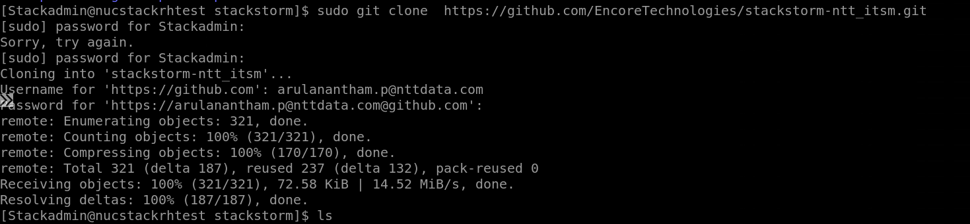
Install the ntt_itsm pack.
sudo st2 pack install file:///opt/stackstorm/stackstorm-ntt_itsm

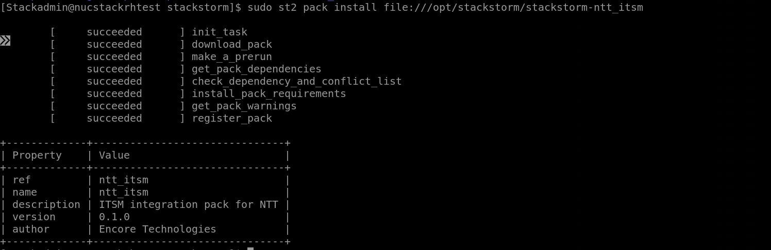
Successfully installed ntt_itsm pack.

Copy the /opt/stackstorm/packs/ntt_itsm/ntt_itsm.yaml.example & paste into /opt/stackstorm/configs/ntt_itsm.yaml
sudo cp /opt/stackstorm/packs/ntt_itsm/ntt_itsm.yaml.example /opt/stackstorm/configs/ntt_itsm.yaml

Validate the files available after the copy command
Change the directory /opt/stackstorm/configs
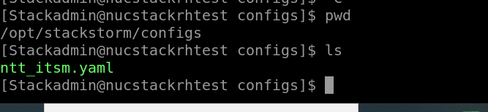

Update the ITSM user name & url details in the ntt_itsm.yaml
After updating the ITSM info, run the below command.
st2ctl reload --register-configs

Install ntt_monitoring pack :
Change the pacth cd /opt/stackstorm
Clone the pack from github repo
sudo git clone https://github.com/NTT-DATAStackStormRepo/stackstorm-ntt_monitoring.git

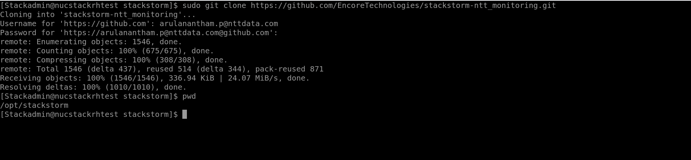
Install the pack:
sudo st2 pack install file:///opt/stackstorm/stackstorm-ntt_monitoring

Successfully installed.
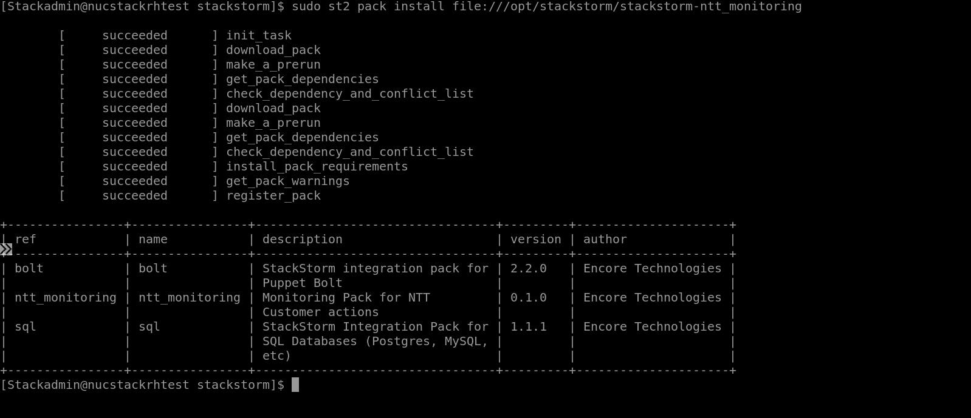

Change the directory
cd /opt/stackstorm/packs/ntt_monitoring
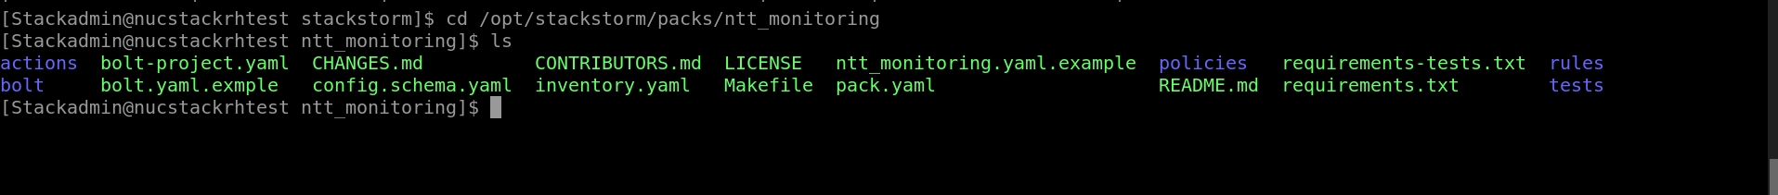
Copy the file :

sudo cp /opt/stackstorm/packs/ntt_monitoring/ntt_monitoring.yaml.example /opt/stackstorm/configs/ntt_monitoring.yaml
sudo cp /opt/stackstorm/packs/ntt_monitoring/bolt.yaml.exmple /opt/stackstorm/configs/bolt.yaml
st2ctl reload --register-configs

Install the bolt module
sudo /usr/local/bin/bolt module install
or
bolt module install
After successful, we got the below message.
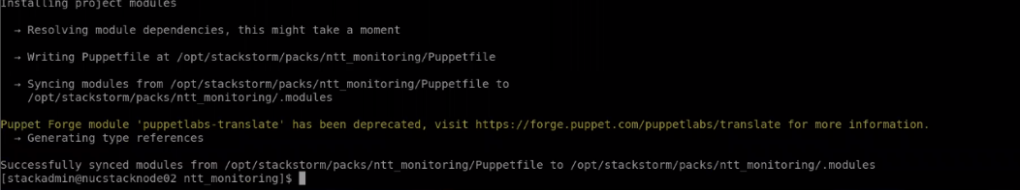

Verify the bolt
[root@nucstacklbdb01 ntt_monitoring]# bolt task show
